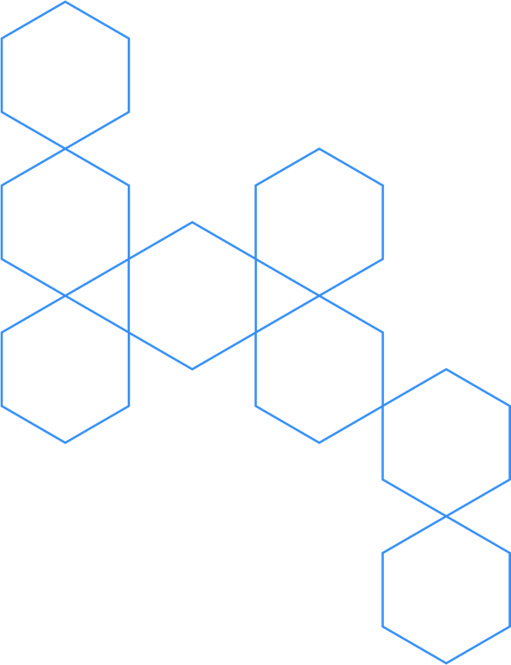

PRESS RELEASE

April 22nd, 2024

### **Egle Therapeutics to highlight novel preclinical findings for regulatory T cells targeting programs EGL-001 and EGL-002 with poster presentations at the 2025 AACR Annual Meeting**

**Paris, France, April 22nd 2025 –** Egle Therapeutics, a clinical-stage biotechnology company developing therapies targeting regulatory T cells (Tregs) for immuno-oncology and autoimmune diseases, will present two posters at the American Association for Cancer Research Annual Meeting (AACR) 2025 being held in Chicago April 25-30, 2025.

In the poster, entitled “Preferential tumor uptake and retention of EGL-001, an anti-CTLA4 -IL2 mutein fusion antibody achieving selective tumor Treg depletion”.

Egle Therapeutics unveils preclinical biodistribution data on EGL-001, a novel anti-CTLA4-IL2 mutein fusion antibody designed to selectively deplete tumor-infiltrating regulatory T cells (Tregs). EGL-001 mode of action combines competitive inhibition of IL-2 signaling and potent downregulation of surface CD25, leading to induction of Treg apoptosis.

*In vivo* EGL-001 preferentially bound to the surface of Tregs due to their high CTLA-4 and CD25 expression and depleted them from the tumor microenvironment without affecting other immune cells. In a biodistribution study, EGL-001 accumulated and persisted in tumors while rapidly clearing from healthy tissues. This targeted approach resulted in deep tumor Treg depletion and was associated with compelling anti-tumor efficacy in multiple mouse tumor models..

EGL-001 is currently under evaluation in a First-In-Human clinical trial (NCT06622486), offering a new therapeutic strategy for alleviating immune suppression mediated by Treg to overcome resistance to immune checkpoint inhibitors.

**Session Title**: Antibodies 3: Multi-Target Checkpoint Inhibitors and Immune Activators**;** **Session Date and Time**: Tuesday Apr 29, 2025 02:00 PM - 05:00 PM; **Location**: Poster Section 37; **Poster Board Number**: 21 **Presentation Number:** 6080

In the poster, entitled “Enhanced anti-tumor efficacy through prolonged plasma membrane retention of a novel anti-CCR8/IL2 mutein fusion antibody”.

Egle scientists present evidence on EGL-002, a novel anti-CCR8/IL2 mutein fusion antibody engineered to enhance Treg depletion in solid tumors. Via the dual binding of CCR8 and CD25 EGL-002 showed prolonged retention on the surface of tumor-infiltrating Tregs, avoiding the rapid internalization that limited the efficacy of conventional CCR8 antibodies. This led to superior ADCC and ADCP potency, resulting in near complete tumor Treg depletion and potent anti-tumor activity in mouse models and *ex vivo* human tumors. These findings position EGL-002 as a best-in-class anti-CCR8 and a promising monotherapy or combination partner for immune checkpoint blockade.

**Session Title**: Enhanced Antibodies, TCR Constructs, Cytokines and Chimeric Proteins**;** **Session Date and Time**: Monday Apr 28, 2025 02:00 PM - 05:00 PM; **Location**: Poster Section 35; **Poster Board Number**: 26 **Presentation Number:** 3767

**About Egle Therapeutics SAS (Egle)**

Egle Therapeutics is a biotechnology company specializing in the development of immunotherapies targeting regulatory T cells. Through its proprietary discovery platform, Egle identifies novel Treg-specific targets and develops innovative Treg-targeting therapeutic candidates for the treatment of cancer and autoimmune diseases.

Egle Therapeutics’ lead immuno-oncology candidate, EGL-001, is currently being evaluated in a Phase I/II clinical trial. In autoimmunity, Egle Therapetics has completed the regulatory studies and manufacturing for EGL-003 preparing to launch a clinical trial in 2025.

Find out more at [www.egle-tx.com](https://www.egle-tx.com).

Contacts

[contact@egle-tx.com](mailto:contact@egle-tx.com) / 0033 (0)1 86 64 08 57

[investor.relations@egle-tx.com](mailto:investor.relations@egle-tx.com) / 0033 (0)1 86 64 08 57